भारत मौसम विज्ञान विभाग | India Meteorological Department

Thursday 14th May 2026 (24th Vaisakha 1948 Saka)

Summary of observations recorded at 0830 hours IST: Conditions are becoming favourable for the advance of southwest monsoon over parts of south Bay of Bengal, Andaman Sea and Andaman & Nicobar Islands around 16th May, 2026. The well-marked low-pressure area over southwest & adjoining westcentral Bay of Bengal persisted over the same region at 0830 Hrs IST of today, the 14th May 2026 and the associated cyclonic circulation extended upto
5.8 km above m. s. l. The upper air cyclonic circulation over northwest Uttar Pradesh & adjoining Uttarakhand lay over west Uttar Pradesh & neighbourhood at 0.9 km above m. s. l. An upper air cyclonic circulation lay over east Uttar Pradesh & neighbourhood at 1.5 km above m. s. l. An upper air cyclonic circulation lay over east Bangladesh & neighbourhood at 0.9 km above m. s. l. The upper air cyclonic circulation over Southwest Madhya Pradesh & neighbourhood lay over southeast Madhya Pradesh & neighbourhood upto 1.5 km above m. s. l. The east-west trough from upper air cyclonic circulation over Southwest Madhya Pradesh to Manipur ran from the upper air cyclonic circulation over southeast Madhya Pradesh to Sub-Himalayan West Bengal & Sikkim across southeast Uttar Pradesh and Bihar at
0.9 km above m. s. l. A trough ran from the centre of well marked low pressure area over southwest & adjoining westcentral Bay of Bengal to south Madhya Maharashtra across north Tamil Nadu, Rayalaseema and North Interior Karnataka at 0.9 km above m. s. l. An upper air cyclonic circulation lay over North Interior Karnataka & neighbourhood at 0.9 km above m. s. l. A fresh Western Disturbance is likely to affect Northwest India from 15th May 2026. he Western Disturbance as an upper air cyclonic circulation over Jammu & neighbourhood lay over Ladakh & neighbourhood at 3.1 km above m. s. l. at 0530 hrs IST of today morning. It then became less marked. The upper air cyclonic circulation over south Haryana & neighbourhood became less marked. The trough in westerly roughly along Long. 92°E to the north of Lat. 21°N became less marked. The north-south trough from Southwest Madhya Pradesh to South Interior Karnataka across Madhya Maharashtra, North Interior Karnataka upto 1.5 km above m. s. l. became less marked.
Maximum Temperature Departures (as on 13-05-2026): markedly above normal (> 5.1°C) at most places over West Madhya Pradesh; at few places over East Madhya Pradesh. appreciably above normal (3.1°C to 5.0°C) at most places over Himachal Pradesh and West Rajasthan; at few places over West Uttar Pradesh. above normal (1.6°C to 3.0°C) at most places over Konkan & Goa; at few places over East Uttar Pradesh and Coastal Andhra Pradesh & Yanam; at isolated places over Tamil Nadu, Puducherry & Karaikal. near normal (-1.5°C to 1.5°C) at many places over Kerala & Mahe; at most places over Rayalaseema, North Interior Karnataka and South Interior Karnataka. The highest maximum temperature of 46.1°C was reported at Jaisalmer (Rajasthan).

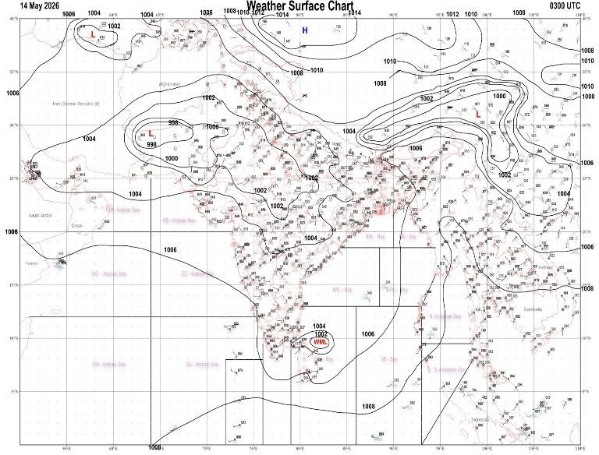 | 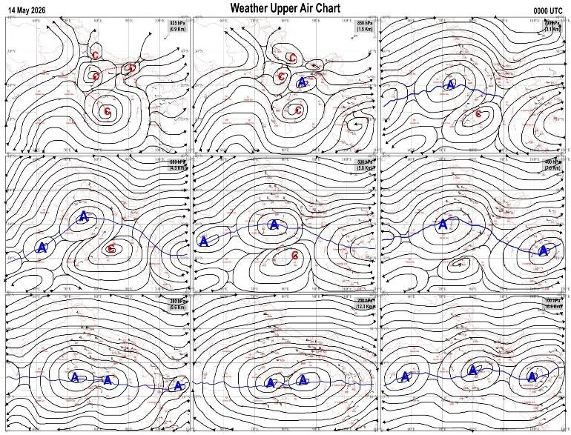
Fig.1. Analysed surface chart based on 03z observation | Fig.2. Analysed upper air chart based on 00z observation

CR & S Office, Pune Issued at 1245 hrs. IST | Weather Forecasting Division CR&S, Pune

Indian regions | Realised rainfall (chief amount in cm during past 24 hrs):
East | many places: Sub-Himalayan West Bengal & Sikkim+++  a few places: Assam & Meghalaya+, Nagaland-Manipur-Mizoram-Tripura, Gangetic West Bengal, Odisha+, Jharkhand and Bihar  isolated places: Arunachal Pradesh  Amfu majhian 11.9, Banki 9.6, Mangan 8.5, Balurghat 7.4, Williamnagar 6.7, Amtala 5.9, Banspal 5.5, Shambhuganj 5.4, Bhaghmara 5.3, Gheropara 4.8, Sangrampur 4.2, Amrapara 3.5, Sri niketan 3.4, Nala 2.8, Jamui 2.5, Cherrapunji, Kailashahar AP & Sundargarh 2.4 each, Chaibasa 2.0, Tawang 1.8, Kanchanpur 1.6,  Naharlagun AWS 1.5, Chhamonu 1.3, Pasighat AP 0.4.
North | isolated places: Uttar Pradesh, Uttarakhand, Haryana, Punjab, Himachal Pradesh, Jammu-Kashmir and Ladakh and Rajasthan  Budhana 3.4, Chamoli 2.8, Munsiyari 2.1, Dharchula 2.0, Sambhal 1.9, Dharmsala & Sardarshahar 1.8 each, Muhammadi & Sikar tehsil SR 1.6 each, Pungal SR 1.5, Birdghat, Karnal & Lolab 1.4 each, Bapouli, Amritsar & Buhama 1.3 each, Karnal AWS 1.2, Sikar 1.1, Basti CWC 1.0, Nangal 0.9, R l bbmb 0.7, Ghanauli & Kufri AWS 0.6 each, Meerut, Kupwara & Ramgarhshekhatan SR 0.5 each.
Central | isolated places: east Madhya Pradesh, Vidarbha and Chhattisgarh  dry weather: west Madhya Pradesh  Mainpur 2.2, Gobra nawapara 1.7, Khairlanji 1.1, Mana-Raipur-AP 1.0, Korpana 0.9, Seoni 0.7, Baihar 0.5, Bhadravati 0.4.
Peninsula | isolated places: Konkan & Goa, Madhya Maharashtra, Marathwada, Telangana, Tamil Nadu, coastal Karnataka, interior Karnataka and Kerala  dry weather: Gujarat State, coastal Andhra Pradesh and Rayalaseema  Annigere ars 5.7, Gokak 5.4, Khutbav daund AWS 4.6, Satara 4.4, Deoni 3.3, Patoda 3.0, N r pura 2.3, Jayapura 2.2, Padegaon ARG 2.1, Haripad 1.7, Nanded IMD parttime & Bhavanisagar 1.6 each, Khanapur 1.5, Utnur & Sathyamangalam 1.3 each, Belagavi AP 1.1, Haliyal & Aralam AWS 0.9 each, Mundgod 0.8, Balehonnur 0.7, Chiplun & Kottayam 0.3 each.
Islands | most places: Andaman & Nicobar  isolated places: Lakshadweep◆  Maya bandar 3.3, Iaf carnicobar 2.4, Hut bay 1.6, Minicoy 0.1.
Table-2 Forecast / warnings (distribution of rain / thundershowers) for 7 days (valid from time of origin upto 0830 hrs IST of next day)
Sr N. | Sub-division Name | Day 1 |  | Day 2 |  |  |  | Day 3 |  | Day 4 |  | Day 5 |  | Day 6 |  | Day 7 |  | Sr.  No. | Sub-division Name | Day 1 |  |  |  | Day 2 |  |  | Day 3 |  |  | Day 4 |  |  |  | Day 5 |  | Day 6 |  | Day 7
 |  | 14 May |  | 15 May |  |  |  | 16 May |  | 17 May |  | 18 May |  | 19 May |  | 20 May |  |  |  | 14 May |  |  |  | 15 May |  |  | 16 May |  |  | 17 May |  |  |  | 18 May |  | 19 May |  | 20 May
1 | Andaman Nicobar Islands | W + |  | W + |  |  |  | W ++ |  | W ++ |  | W + |  | W |  | W |  | 19 | west Madhya Pradesh |  | I | + |  | D | + |  | D |  | + |  | D | + |  | D | + | D  + |  | D  +
2 | Arunachal Pradesh | F + |  | S + |  |  |  | S + |  | F |  | F |  | F |  | F |  | 20 | east Madhya Pradesh | I  |  |  |  | D | + |  | D |  | + |  | D | + |  | D | + | D | + | D | +
3 | Assam-Meghalaya | W ++ |  | W + |  |  |  | F + |  | F + |  | F ++ |  | F + |  | F + |  | 21 | Gujarat region |  | D | + |  | D |  |  | D |  |  | D |  |  |  | D |  | D |  | D
4 | Nagaland-Manipur- Mizoram-Tripura | F |  | F |  |  |  | S |  | F+ |  | F + |  | F + |  | F + |  | 22 | Saurashtra and Kutch |  | D | + |  | D | + |  | D |  |  | D |  |  |  | D |  | D |  | D
5 | Sub Him West Bengal/Sikkim | W + |  | F + |  |  |  | F ++ |  | F ++ |  | S |  | S |  | S |  | 23 | Konkan and Goa |   I  + |  |  |  |   I |  | + |   I | + |  | I |  |  |  | I |  | I |  | I
6 | Gangetic West Bengal | I |  | I |  |  |  | I |  | I |  | I |  | I |  | I |  | 24 | Madhya Maharashtra |   I |  |  | + | I  |  |  | I  |  |  | I |  |  |  | I |  | I |  | I
7 | Odisha | S |  | I |  |  |  | I |  | I |  | I |  | I |  | I |  | 25 | Marathwada | I   + |  |  |  | I   + |  |  | I  |  |  | I |  |  |  | I |  | D |  | D
8 | Jharkhand | I |  | I |  |  |  | I |  | I |  | S |  | I |  | I |  | 26 | Vidarbha |   I |  |  | + |   D |  | + | D |  | + |  | D | + |  | D | + | D | + | D | +
9 | Bihar | I |  | I |  |  |  | F |  | S |  | I |  | I |  | I |  | 27 | Chhattisgarh | I  |  |  |  | I  |  |  | I  |  |  |   I |  |  | + | D | + | D | + | D | +
10 | east Uttar Pradesh | I | + |  | D | + |  | D | + | D | + | D | + | I | + | I | + | 28 | Coastal Andhra Pradesh and Yanam | I  |  |  |  | I  |  |  | I  |  |  | I  |  |  |  | I |  | I |  | I
11 | west Uttar Pradesh | I |  |  | D | + |  | D | + | D | + | D | + | D | + | D  + |  | 29 | Telangana | I  |  |  |  | I  |  |  |   I | + |  |  | D | + |  | D | + | D |  | D
12 | Uttarakhand | I |  | I |  |  |  | I |  | I |  | D |  | D |  | D |  | 30 | Rayalaseema | I  |  |  |  | I  |  |  | I  |  |  | I  |  |  |  | I  |  | I |  | I
13 | Haryana,Chandigar h and Delhi | I |  | I |  |  |  | D | + | D | + | D | + | D | + | D | + | 31 | Tamil Nadu, Puducherry and Karaikal | I + |  |  |  | I + |  |  | I + |  |  | I + |  |  |  | I + |  | I + |  | I
14 | Punjab | I |  | I |  |  |  | D | + | D | + | D | + | D | + | D | + | 32 | Coastal Karnataka | I  |  |  |  | I  |  |  | I |  |  | I |  |  |  | I |  | D |  | D
15 | Himachal Pradesh | I |  | I |  |  |  | I |  | I |  | D |  | D |  | D |  | 33 | North interior Karnataka |   S |  |  |  | I  |  |  | I  |  |  | I  |  |  |  | I  |  | D |  | D
16 | Jammu-Kashmir and Ladakh | I |  | S |  |  |  | S |  | D |  | D |  | I |  | I |  | 34 | South interior Karnataka |   S |  |  |  | S +  |  |  |   S+ |  |  |   S+ |  |  |  | I  |  | I |  | I
17 | west Rajasthan | I | + | I |  |  | + | D | + | D | + | D | + | D | + | D | + | 35 | Kerala and Mahe |   W+ |  |  |  | W+  |  |  |   W+ |  |  |   F+ |  |  |  | F  |  | F |  | F
18 | east Rajasthan | I | + | I |  |  |  | D |  | D | + | D | + | D | + | D | + | 36 | Lakshadweep | F  |  |  |  | F  |  |  | F |  |  | F |  |  |  | F |  | F |  | F
Legends: D = Dry I =isolated S = Scattered F = Fairly widespread W = Widespread #= heavy to very heavy rain at a few places with extremely heavy rain at isolated places+++= heavy rain at a few places with very heavy rain at isoIated places++= heavy to very heavy rainfall @=isolated exceptionally heavy rainfall+ = heavy rain ●/*= rain or snow ♦ = very light rain ≡=fog = thunderstorm with lightning =Squall / Gusty / gale / strong wind -=cold wave/cold day + = heat wave/warm night/hot and humid weather =Duststorm =ground frost = Hail.

Fig. 4: Districtwise warnings for five days for Maharashtra State

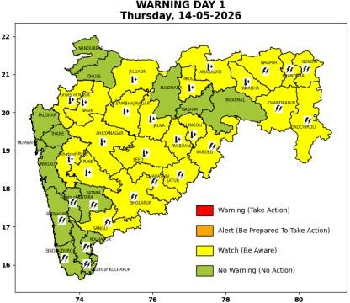 | 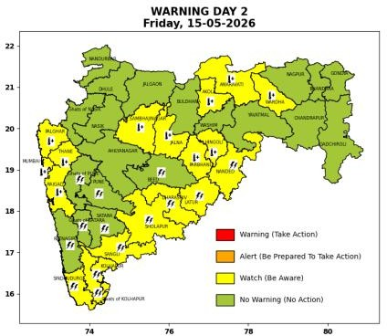 | 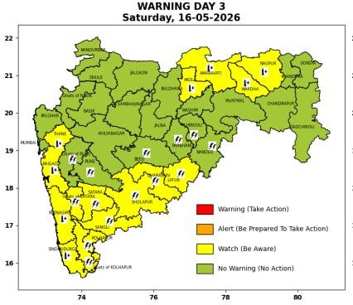 | 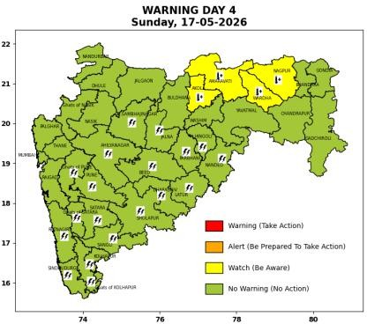 | 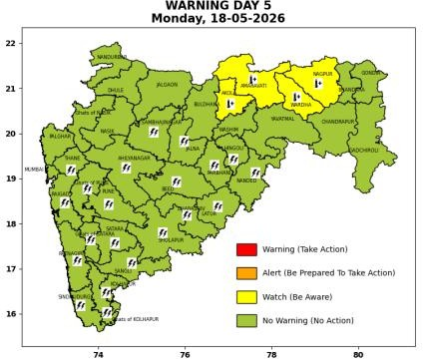

Pune, Lohegaon and Pashan observations at 0830 hrs. IST of Today
 | Temperature (°C) |  |  |  |  | Humidity (%) |  |  |  | Rainfall (mm)
 | Max. past 24 hrs | Dep. from normal | Min. past 24 hrs. | Dep. from normal | Dry Bulb | At 0830 hrs. IST | Dep. From normal | At 1730  hrs. IST of y’day | Dep. from normal | Past 24 hrs. | Since 1st March | Dep. from normal
PNE | 39.0 | 1.5 | 25.7 | 3.4 | 28.8 | 51 | -4 | 46 | 12 | 0.0 | 92.8 | 70.0
PSN | - | - | 24.7 | - | 27.0 | 71 | - | - | - | 0.0 | - | -
LHG | 41.4 | 3.4 | 27.2 | 6.2 | 31.1 | 41 | -17 | 31 | -1 | 0.0 | 91.4 | 63.3

Local (Pune and neighbourhood) forecast
Max./Min. Temperature (°C) |  |  |  |  |  |  |  |  | Weather
Date | Pune | Pashan | Lohegaon | Chinchwad | Lavale | Magarpatta | NDA | Koregoan park
14/05/26 | 39 / 25.7* | 38 / 24.7* | 41 / 27.2* | 37 / 25.7* | 37 / 22.6* | 40 / 27.4* | 36 / 24.8* | 39 / 27.3* | Mainly clear sky becoming partly clear sky towards afternoon or evening.
15/05/26 | 39 / 26 | 38 / 25 | 41 / 27 | 38 / 26 | 37 / 23 | 41 / 27 | 37 / 25 | 39 / 27 | Mainly clear sky becoming partly clear sky towards afternoon or evening.
16/05/26 | 39 / 26 | 38 / 25 | 41 / 27 | 38 / 26 | 37 / 23 | 41 / 27 | 37 / 25 | 39 / 27 | Mainly clear sky becoming partly clear sky towards afternoon or evening.
17/05/26 | 38 / 26 | 37 / 25 | 40 / 27 | 37 / 26 | 36 / 23 | 40 / 27 | 36 / 25 | 38 / 27 | Mainly clear sky becoming partly clear sky towards afternoon or evening.
18/05/26 | 38 / 25 | 37 / 24 | 40 / 26 | 37 / 25 | 36 / 22 | 40 / 26 | 36 / 24 | 38 / 26 | Mainly clear sky becoming partly clear sky towards afternoon or evening.
19/05/26 | 37 / 25 | 36 / 24 | 39 / 26 | 36 / 25 | 35 / 22 | 39 / 26 | 35 / 24 | 37 / 26 | Partly cloudy sky.
20/05/26 | 37 / 24 | 36 / 23 | 39 / 25 | 36 / 24 | 35 / 21 | 39 / 25 | 35 / 23 | 37 / 25 | Partly cloudy sky.
* = realized temperatu
Mumbai (Colaba) |  |  |  | Nagpur (AP)
Date 2026 | T max °C | T min °C | Weather | T max °C | T min °C | Weather
14/05/26 | 35 | 28 | Clear sky. | 44 | 27 | Thunderstorm with rain. Thunderstorm accompanied with Lightning.
15/05/26 | 36 | 28 | Heat Wave. | 44 | 27 | Partly cloudy sky.
16/05/26 | 35 | 28 | Clear sky. | 45 | 26 |  | Heat Wave.
17/05/26 | 34 | 28 | Clear sky. | 45 | 26 |  | Heat Wave.
18/05/26 | 34 | 28 | Clear sky. | 45 | 26 |  | Heat Wave.
19/05/26 | 34 | 28 | Clear sky. | 45 | 26 |  | Heat Wave.
20/05/26 | 34 | 28 | Clear sky. | 45 | 26 |  | Heat Wave.

Rainfall Distribution |  |  | Rainfall Categories | Rainfall (mm) | Cloud condition |  | Rainfall Intensity | Range
Widespread (W) | 76-100% |  | Very Light rain | Trace to 2.4 mm | Mainly clear sky | 1-2 oktas | Light Spell | 1 cm/hr
 |  |  | Light rain | 2.5 to 15.5 mm | Partly cloudy sky | 3-4 oktas | Moderate Spell | 1-2 cm/hr
Fairly Widespread (FW) | 51 – 75% |  | Moderate rain | 15.6 to 64.4 mm | Generally cloudy sky | 5-7 oktas | Intense Spell | 2-3 cm/hr
Scattered (S) | 26 – 50% |  | Heavy rain | 64.5 to 115.5 mm | Overcast | 8 oktas | Very Intense Spell | 3-5 cm/hr
Isolated (I) | 1 – 25% |  | Very heavy rain | 115.6 to 204.4 mm |  |  | Extremely Intense Spell | 5-10 cm/hr
Dry (D) | No Rain |  | Extremely heavy rain | ≥ 204.5 mm |  |  | Cloudburst | > 10 cm/hr
Probability Terms in %: |  |  | Heavy snow | 6.5 to 11.5 cms water equivalent of rain
unlikely | < 25 |  | Very heavy snow | 11.6 to 20.4 cms water equivalent of rain
likely | between 25 50
very likely | between 51 75
most likely | >75

